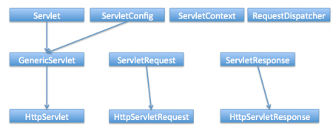

**RequestDispatcher interface**

RequestDispatcher interface is used to forward the request to another resource that can be HTML, JSP or another servlet in the same context. We can also use this to include the content of another resource to the response. This interface is used for servlet communication within the same context.

There are two methods defined in this interface:

1. **void forward(ServletRequest request, ServletResponse response)** – forwards the request from a servlet to another resource (servlet, JSP file, or HTML file) on the server.
2. **void include(ServletRequest request, ServletResponse response)** – includes the content of a resource (servlet, JSP page, HTML file) in the response.

We can get RequestDispatcher in a servlet using ServletContext getRequestDispatcher(String path) method. The path must begin with a / and is interpreted as relative to the current context root.

**ServletResponse interface**

ServletResponse interface is used by servlet in sending response to the client. Servlet container creates the ServletResponse object and pass it to servlet service() method and later use the response object to generate the HTML response for client.

Some of the important methods in HttpServletResponse are:

1. **void addCookie(Cookie cookie)** – Used to add cookie to the response.
2. **void addHeader(String name, String value)** – used to add a response header with the given name and value.
3. **String encodeURL(java.lang.String url)** – encodes the specified URL by including the session ID in it, or, if encoding is not needed, returns the URL unchanged.
4. **String getHeader(String name)** – return the value for the specified header, or null if this header has not been set.
5. **void sendRedirect(String location)** – used to send a temporary redirect response to the client using the specified redirect location URL.
6. **void setStatus(int sc)** – used to set the status code for the response.